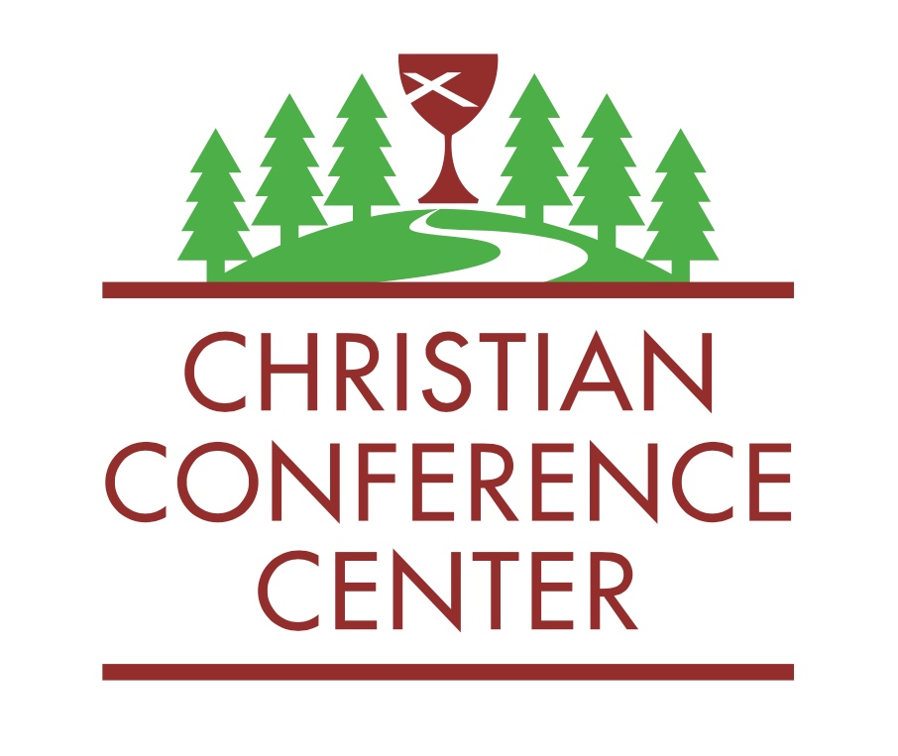

Dear Brothers and Sisters in Christ,

Are you ready for an adventure? Are you ready to spend your summer on Holy Ground? There is absolutely no life like camp life. If you come work for us, you’ll find out why. Our internship program has been growing and changing for over 20 years. We hope that this summer will be the best one yet. Past interns have gone on to be pastors, missionaries, social workers, regional ministers, camp directors and counselors, leaders in the General Church, CCC full-time employees, gifted lay leaders, and more. We promise to help make you the best leader you can be so that you can go on and do the amazing things God is dreaming up for you. Are you up for the challenge?

At its foundation, our summer internship is about service and it’s about you. It’s about service because there are long hours and hard work involved in camping ministry. Interns will try to live out the servant leadership that we see modeled by Jesus in the Gospels. It is an amazing opportunity for those who feel called to do so to put the needs of others before their own. It’s also about you because it is our goal that our summer interns work hard, play hard and have time for their own spiritual growth. All summer you will have the opportunity to participate in devotionals and prayer with your fellow interns, be part of a weekly Bible study and leadership conversations with gifted leaders around the denomination, and have the option to attend campfire and worship with our groups. We hope you will decide to join us on this adventure.

Here are a few details about the job:
- You will be paid $4,000, plus room and board, if you stay the entire summer. Each intern who chooses to become lifeguard certified will be paid an additional $500 stipend.
- Our work begins at 1:00 pm on Tuesday, May 30th, 2023. Some limited time off can be worked out in advance.
- We hope all interns can stay until August 12, 2023 but your end date is flexible.
- Most weeks you will be off after clean up on Saturday until Sunday evening
- You will occasionally be on call to assist directors with evening programming and/or worship.
- You will also work one weekend camp (Grand Camp or Family Camp).
- It takes a lot to run a camp, including: grounds upkeep, maintenance, kitchen work, registration paperwork, plus the typical fun and games associated with camp. You will be involved in every aspect of our ministry and have the opportunity to learn new skills. You name it and we’ll teach you how to do it.
- You will have many opportunities for your own spiritual growth, including: conversations with mentors, prayer groups, Bible study, worship and more.

If you think you’re up for this once in a lifetime challenge, please fill out the online application at newtonccc.org by 5:00 pm on Monday, March 15, 2023.

Grace and peace,

Tiff Williams
CCC Camp Director
Associate Regional Minister
Christian Church in the Upper Midwest
What to Expect at the CCC
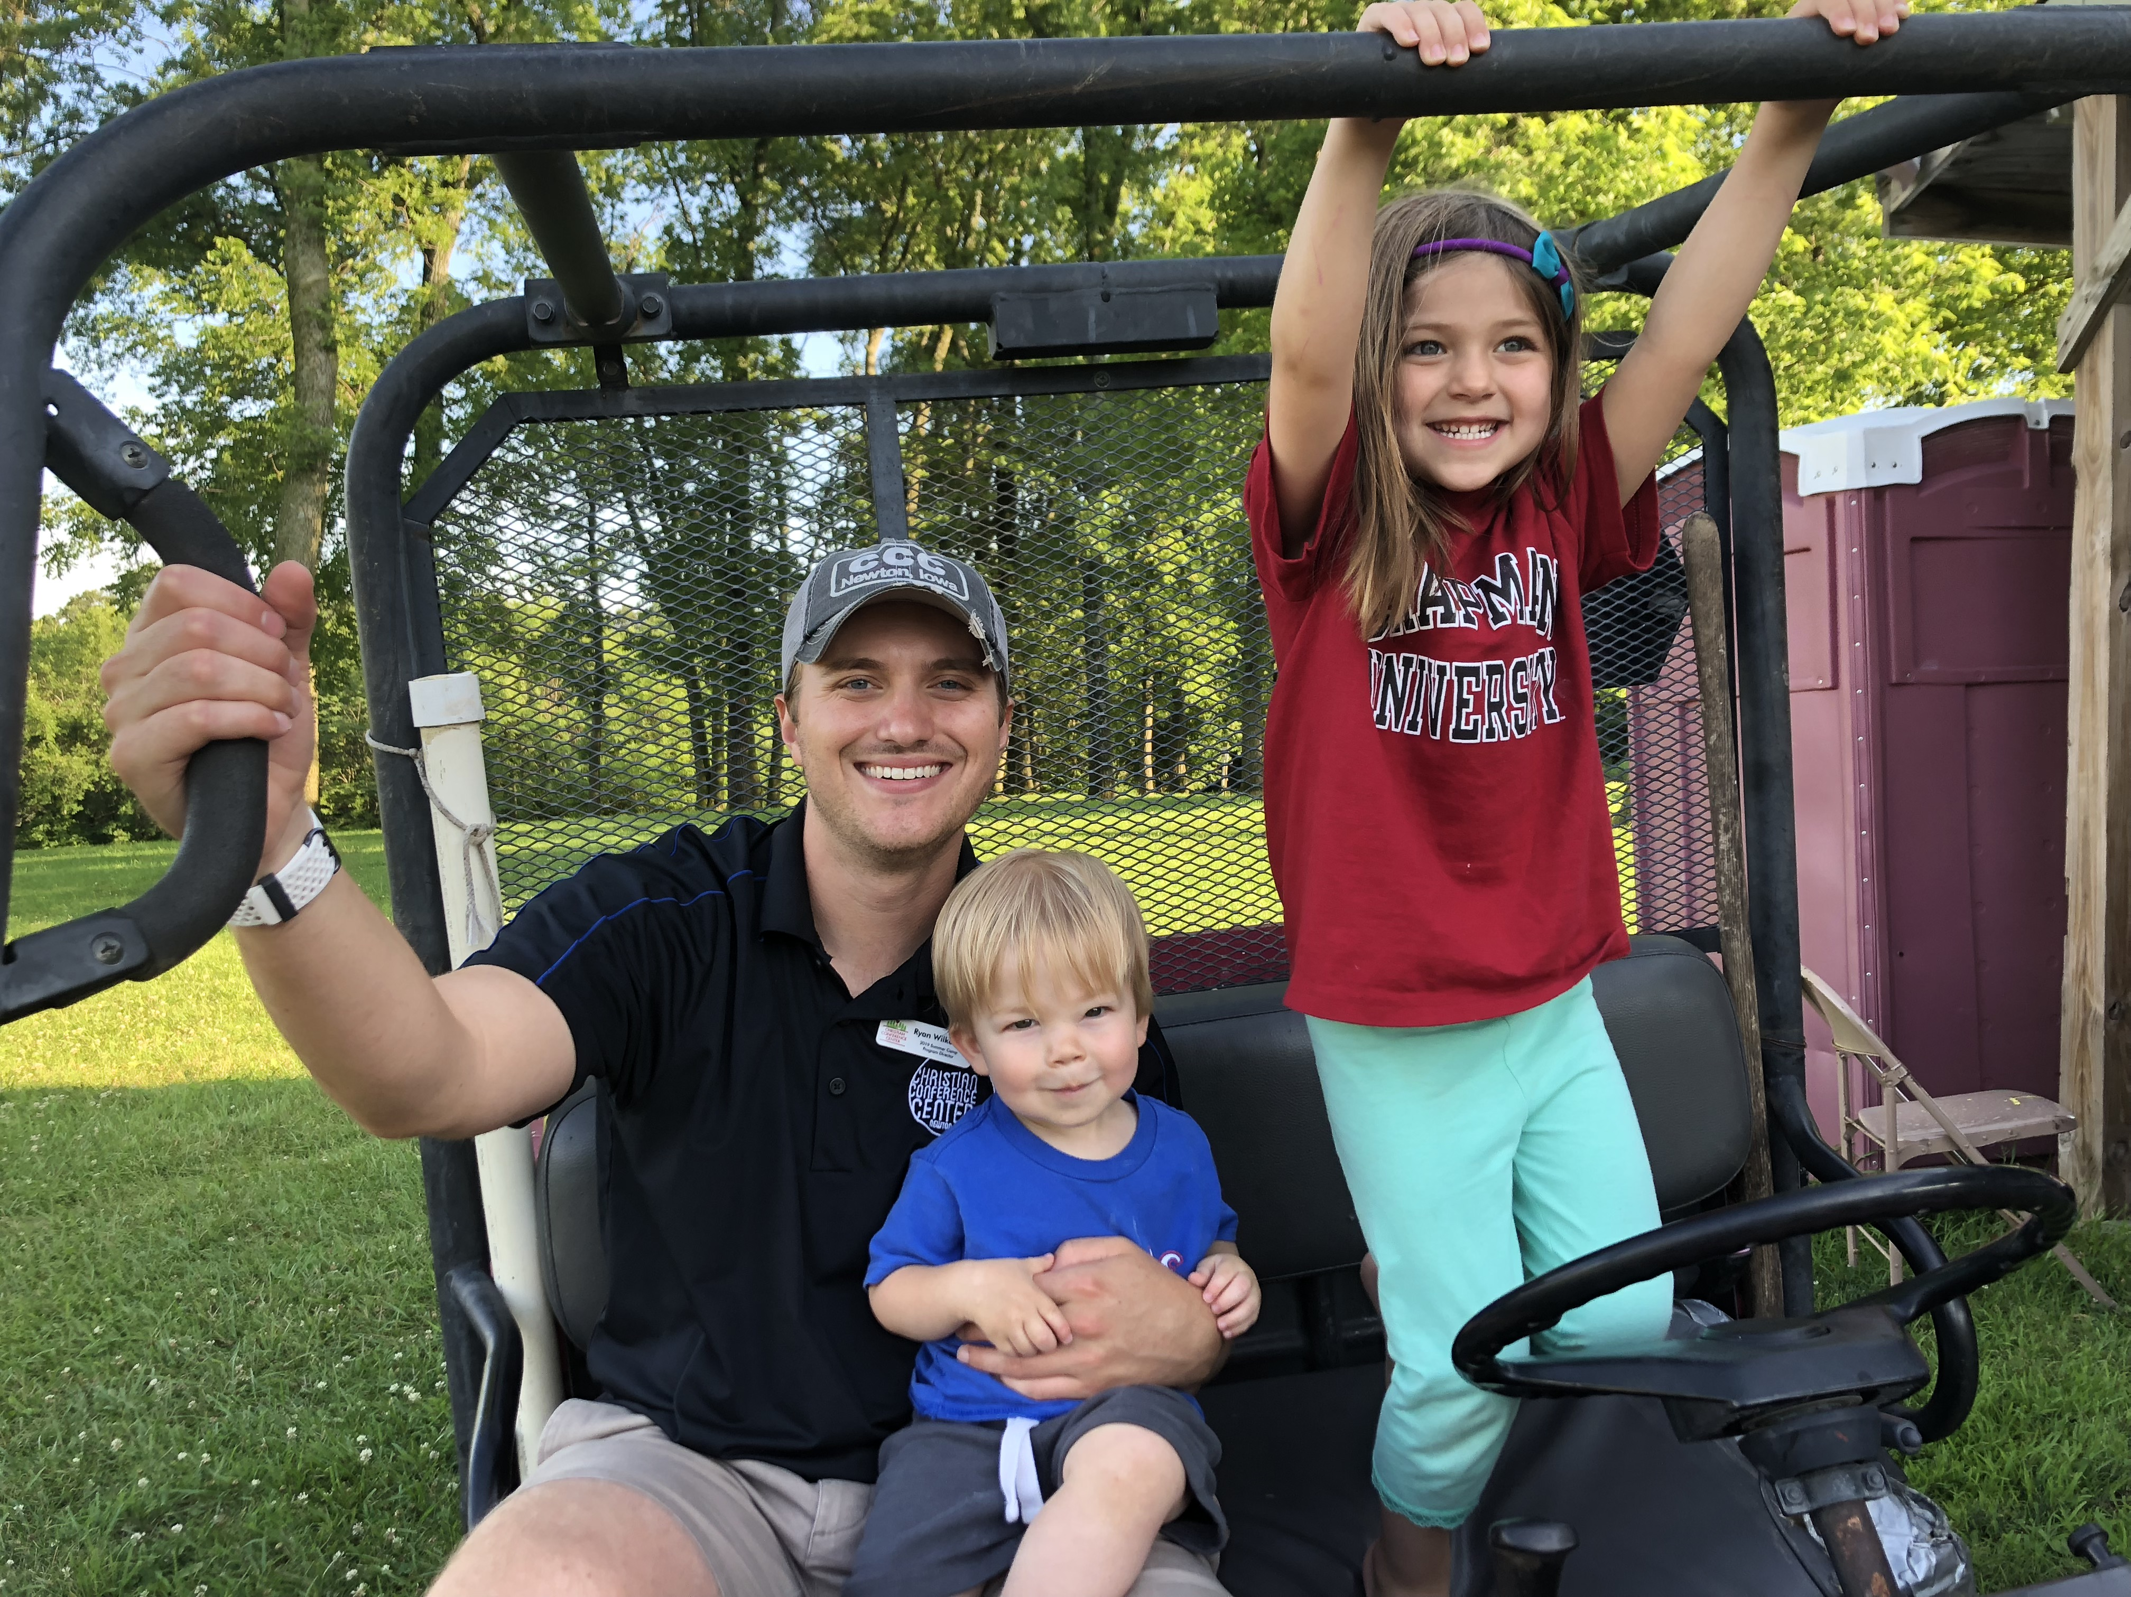
Interns rotate through different responsibilities on a weekly basis: office, maintenance, kitchen and “Camp Intern”. Camp Interns are celebrities at our camp. On the weeks where you are the designated Camp Intern, you are the directors’ right hand and assist them with every aspect of their camp. You’ll have the opportunity to choose which age groups you would like to work with the most and you’ll be the Camp Intern approximately 4 times during the summer.

We’ll be frank: kitchen and maintenance work can be hard work. It is balanced out by the rewarding time we spend in face to face ministry with our campers on the weeks you’re the designated Camp Intern. In everything we do, we try to have a spirit of joy about our work for “God loves a cheerful giver”. On weeks where you are the primary intern for Chi Rho Camp (our rustic camp), you’ll assist with food runs and trash pick-up, in addition to other duties. Interns spend about 75% more time as Camp Intern than they do as kitchen/maintenance work.

In addition to these experiences, if you wish, you can be on staff as a counselor at least one week out of your internship. This week you’ll focus totally on face to face ministry with kids. (You can select the age group you’d like to work with.)

Skills You Will Develop

- Anything that interests you about Camp Life! Past interns have set goals that we work on throughout the summer. Some examples:
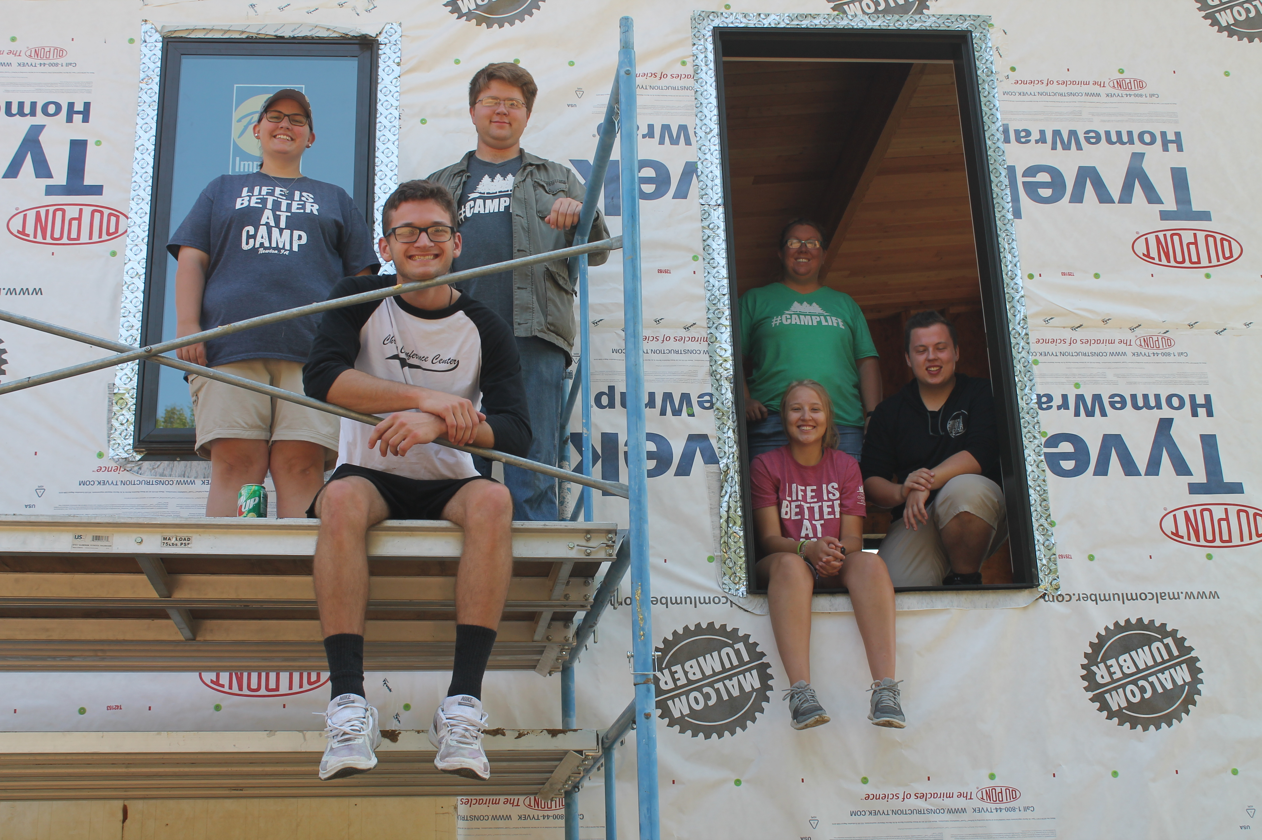
  - Tractor driving
  - Driving a 5 speed vehicle
  - Communication and public speaking
  - Business basics
  - Culinary arts and cake decorations
  - You name it… we will help you learn it

- Effective Communication skills
  - help you work with diverse groups of people
  - help you work better with peers
  - help you learn to listen for the needs of others
  - help understanding what others need from you so they can succeed

- Discernment about your call to ministry, either as a layperson or a future pastor

- Worship leadership
  - how to plan meaningful worship
  - how to lead meaningful worship
- Public speaking (interns are often asked to give their testimony at Campfire – this is optional)
- Ability to think outside of the box and solve problems quickly
- Team dynamics are essential. You will learn to master them. You will also learn to lead others through activities that make them a better team.
- Outdoor nature skills such as:
  - being comfortable outdoors
  - setting up camp sites
  - leading nature hikes
  - building campfires

Annual Intern Retreat
We start off our season with an intern retreat just for you. Here are a few highlights…

- Bond with the people you’ll be working with all summer
- Get to know the year-round CCC staff a little better
- Complete physical and mental challenges that test your abilities
- Create a “faith map” that tracks where you’ve been
- Set “faith goals” to get you to where you want to be
- Learn some essential intern tasks like how to build a cool looking campfire
- Learn curriculum we’ll use for the summer so that you can be prepared to assist directors

Leadership Learning Sessions
This year we’re adding weekly leadership component to our time together. We’ll have Q and A sessions with leaders all over our denomination, but in person and via zoom.

Bible Study
We will take time each week to dig deeper in scripture. We’ll focus on a study called “How to Talk About the Bible Without Embarrassing Yourself”. It’s a great study that makes the average faith leader more confident in talking about what they believe and why they believe it.

Faith Goals
Set a goal and we will help you meet it, no matter how big or small. We are here to help you improve yourself and your faith. We want your faith to grow while you’re here, and to sustain you after you leave.

A Day in the Life of an Intern…

During Registration: Everyone shares these responsibilities…
All hands on deck!
Greeters at the road
Assist directors as campers register
Run Camp Store
Help everyone get settled into their routines
Be welcoming and helpful in any way possible!

Full Days of Camp: Cabin Side Intern
AM: Be present (and awake) at breakfast
Make sure your camp’s curriculum bins are ready to go
Prepare for morning games
Ask director what is needed from you
Assist with mail sorting
Check supplies in cabins that are in use

PM: Attend daily CCC staff meeting
Help setup evening activity as needed
Be present to help with snack
Prepare campfire

Rustic Side Intern
AM: Chi Rho staff meeting games
Check supplies in bath house before returning to Cabin Side
Ask director what else is needed before returning to Cabin Side
Be in the kitchen by 11:00 to help with Chi Rho lunch run
Bring mail to Chi Rho with lunch

PM: Right after lunch: bring Chi Rho dishes up for washing
Assist with set up for Daily Challenges
Attend daily staff meeting
Be in the kitchen for by 4:30 for food run at 5:00 pm
Help with evening activity as needed
Supper dishes and trash run at 7:00 pm
Prepare campfire

Office “Floater” Intern
AM: Be present in the Dining Hall at 8:00 am for breakfast
Assist with dishes as needed
Assist with camp games as needed
Print camper emails
Go to mailbox and sort mail – needed before lunch
Be in the office to catch phone messages or out on grounds as assigned

PM: Assist with serving and lunch dishes as needed
Assist with Chi Rho Daily Challenges and food run prep
Assist other interns with prep for evening activities
Help Facility Director with grounds work
Attend daily staff meeting
Break
Supper dishes
Good night!

Kitchen Intern
AM: Be present in the Dining Hall at 7:00 am for breakfast prep
Assist with dishes as needed
Assist with camp games as needed
Begin lunch prep (ask Lead Cook what time to be there)

PM: Assist with lunch dishes as needed
Break
Attend daily staff meeting
Check Lodge bathrooms
4:00 pm - Prepare Chi Rho Run (if necessary) to be ready by 4:45 pm
Begin supper prep
Supper dishes
Set out evening snack and tell others where snack is located
Sweep and mop kitchen floor as needed
Good night!

During Check Out: Everyone shares these responsibilities
Make sure directors have last day items: evaluations, Jr ribbons, Chi Rho tiles, CYF mugs, check out sheets
Collect camper and counselor evaluations from directors before they leave
Check campers out of huts and cabins to verify they were cleaned
Inspect cabins and restrooms before the camp leaves
Clean where needed

Go home to get some rest!

